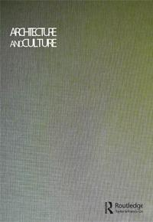**Architecture and Culture**

**ISSN: 2050-7828 (Print) 2050-7836 (Online) Journal homepage:** [**https://www.tandfonline.com/loi/rfac20**](https://www.tandfonline.com/loi/rfac20)



**Fragments and Visions of a Spatial Discourse: Re-Viewing Georges Perec’s *Species of Spaces***

**Patrizio M. Martinelli**

**To cite this article:** Patrizio M. Martinelli (2020): Fragments and Visions of a Spatial

Discourse: Re-Viewing Georges Perec’s *Species of Spaces*, Architecture and Culture, DOI:

[10.1080/20507828.2020.1714323](https://www.tandfonline.com/action/showCitFormats?doi=10.1080/20507828.2020.1714323)

**To link to this article:** <https://doi.org/10.1080/20507828.2020.1714323>



Published online: 16 Apr 2020.



[Submit your article to this journal](https://www.tandfonline.com/action/authorSubmission?journalCode=rfac20&show=instructions) 



Article views: 60



[View related articles](https://www.tandfonline.com/doi/mlt/10.1080/20507828.2020.1714323) 



[View Crossmark data](http://crossmark.crossref.org/dialog/?doi=10.1080/20507828.2020.1714323&domain=pdf&date_stamp=2020-04-16)



Full Terms & Conditions of access and use can be found at

<https://www.tandfonline.com/action/journalInformation?journalCode=rfac20>

ARCHITECTURE AND CULTURE

Patrizio M. Martinelli

Department of

Architecture þ Interior Design,

Miami University, Oxford,

OH, USA

martinpm@miamioh.edu

Keywords: Perec, space, architecture, city, house, interior, theatre, collage



1. 1–21 DOI:10.1080/20507828. 2020.1714323

No potential conflict of interest was reported by the author.

© 2020 Informa UK Limited, trading as Taylor & Francis Group

This article has been corrected with minor changes. These changes do not impact the academic content of the article.



1

Fragments and Visions of a Spatial Discourse: Re-Viewing Georges Perec’s

Species of Spaces

Patrizio M. Martinelli

ABSTRACT This article accompanies a visual essay that re-views Georges Perec’s 1974 book Species of Spaces through a series of col-lages inspired by its most important chapters related to architecture and city. The overlapping of these two scales, the domestic and the urban, invites us to read the spaces of our lives as interior stages and the city as a “big house,” necessary for the expression and representa-tion of ourselves and our communities. The article situates the tech-nique of collage within Perec’s own creative approach, reflecting on its capacity to find a balance between analytical description and poetic suggestion, between reality and invention, between abstraction and memory.

There are books not written by architects or designers that are important for these disciplines because of the different points of view they offer. They become a powerful instrument and a fertile container of possibilities, both for theoretical reflection and design intervention. One of these books is Species of Spaces, written in 1974 by Georges Perec.1 Here, I return to review this book, and just as Perec was inspired by a drawing to write Life: A User’s Manual,2 I mirror this process in a series of collages that respond to the main chapters of Species of Spaces.

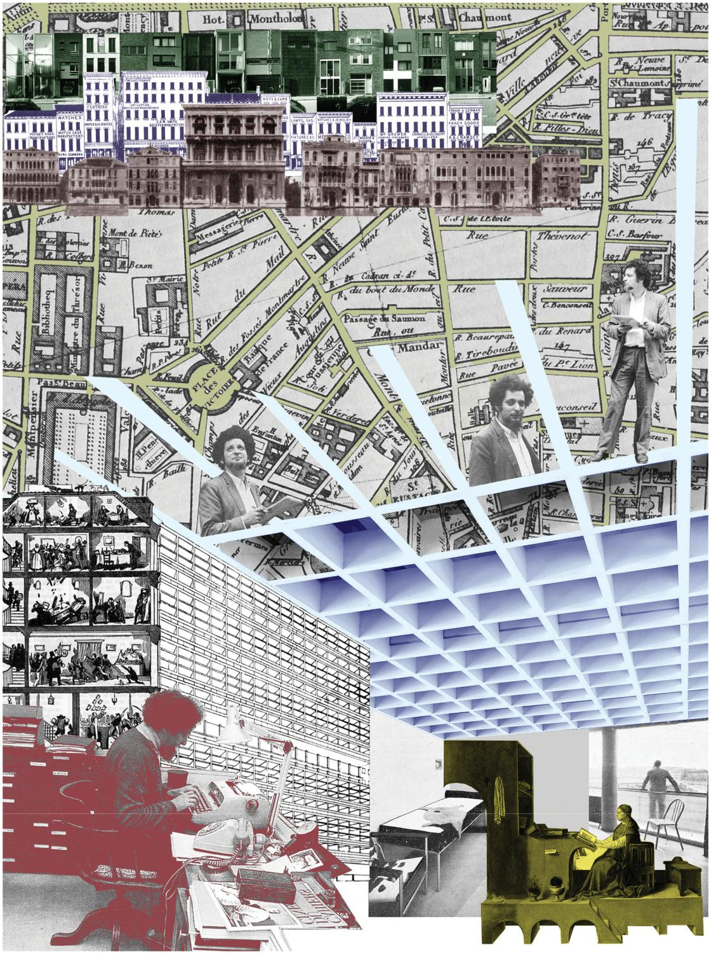

Figure 1

Species of Spaces. Collage by Patrizio M. Martinelli.

|  |  |
| --- | --- |
| This return involved another kind (another species) of re-viewing, brought | 3 |

about by the use of various translations of Perec’s books. Working on this project, I used the English translations, although I had previously been familiar with the Italian version of Species of Spaces: my visual approach to the collages could be related to the various transitions I experienced, moving from language to language (French–Italian–English). In an almost unconscious way, the choice of the montage of images becomes another necessary translation, a transfiguration that transcends the page and the idiom. Transition, translation, transfiguration, transcendence: these words share the common Latin prefix trans, meaning “beyond.” My approach to the book, through visual descriptions and evocative compositions, encourages us to go beyond words, languages, and places.

Following an analysis of Perec’s working processes and preoccupations, the inception and format of the essay presented here (the idea of using visual elements and a text, of manipulating images and words in order to evoke more than explain), stands in a particular position in the context of book reviewing. This investigation is the work of an architect and designer, not a literary scholar or a literary critic, not an architectural historian or a theoretician: as such, I approach and use the book as an instrument (as a physical object and as a container of concepts and ideas), and re-read and review the text through the lenses of my own autobiography. This way of interpreting Perec’s work is derived from an understanding of the writer himself. As Tania Ørum points out, his connections and interests in the visual arts were:

evident from Perec’s own statements about his collaborative projects with visual artists, which stress that what he aims to do in his work with an artist is to ‘look at how he works’ and ‘then try to transfer to my own work something which will stick to what he does, but which is not a comment’. As Bernard Magne has demonstrated, the relation between text and image in these collaborative projects is ‘not an anecdotal and illustrative relation

* but a structural relation at the level of productive activity’.3

Perec actually wanted to be a painter.4 His favorite painter was Paul Klee (“Klee appears to me as a mirror,”5 “each painting by Klee is the solution to a different problem. I am like Klee.”6) One of his favorite paintings was “St. Jerome in his Study” by Antonello da Messina, and painters are some of the main protagonists of his novels (Life: A User’s Manual, Un cabinet d’amateur). He knew very well (and he was probably inspired by) a painting that represents a montage of fragments of views of urban places in Paris made by his friend Pierre Glatzer in 1971/72, the same period he was working on Species of Spaces.7

As a writer interested in the visual arts, and with the intention of transferring ideas and approaches between disciplines, Perec often tried

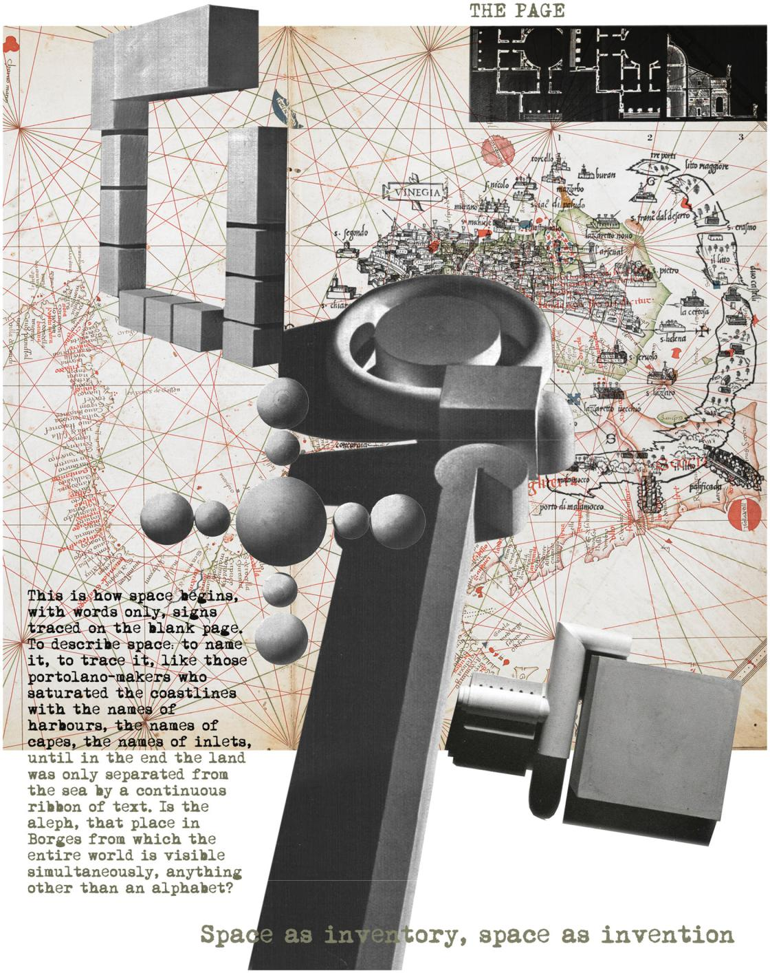

Figure 2

The Page. Collage by Patrizio M. Martinelli.

|  |  |
| --- | --- |
| to re-compose the well-known dichotomy expressed by Lessing,8 who | 5 |

pointed out that the relationships between elements of space are expressed in painting (image), while the temporal dimension of these relationships is represented in poetry (text). As David Gascoigne explains, “Perec’s novel … constantly pressurizes this dichotomy: with its strategies of overflow and saturation it challenges painting’s home territory of spatiality, but it also deploys the narrative vocation of language by shifts” into memories, past lives of inhabitants, descriptions of furniture, through a narrative “freed from any temporal anchor.”9 This happens very clearly when Perec incorporates descriptions of paintings (and their parts), in his narrative. One example is Antonello da Messina’s “St. Jerome,” which is accurately depicted in words in the last pages of Species of Spaces. But fragments of this painting reappear, transfigured, in other contexts: in Life: A User’s Manual we can find, in the description of Madame Moreau’s kitchen, the wooden study’s shelving with several objects and the floor pattern of the cathedral, while the red hat of the saint can be recognized in at least two chapters of the novel.10 This is clearly related also to the collage technique used in literature that Perec often applied, not only sampling his own writings.11 In Life, for example, he incorporates texts by Borges, Kafka, Mann, Rabelais, Stendhal, Proust, Joyce, Calvino, to name just a few.12 These appear not as recognizable quotations but as part of his own narration. So for me, using the collage/ montage technique has been a natural and reciprocal way of re-viewing and translating the main aspects of Species of Spaces from the written page (back) to a visual discourse.

Georges Perec was one of the most important, versatile and innovative European writers of his generation.13 Although neither an architect nor a designer, he was arguably a builder. The most famous piece of architecture he made is Life: A User’s Manual, a book which is a building; a piece of literature which is, at the same time, an architecture whose spaces are built on geometry and structure (concepts clearly related to the composition and tectonic of architecture) in order to host the actions and lives of its inhabitants, Perec’s characters.14

As a necessary premise to this novel, he wrote Species of Spaces, a book that is a collection of essays, a list of descriptions, a sort of dictionary, a journal of memories, a notebook of written sketches, the origin of other books.15 Species of Spaces is all of this and more. It’s a book about space, about the different scales of space (furniture, architecture, city, landscape), each one related to man. This is what interests Perec: not the empty space that we very often see photographed in architectural books and magazines, but the space that is closer to our experience and actions. The space for people, the space filled with life: “We live in space, in these spaces, these towns, this countryside, these corridors, these parks … This is how space begins,”16 Perec tells us in the first pages of the book, with an empty page (the empty space) filled by words little by little (concepts, persons, actions),

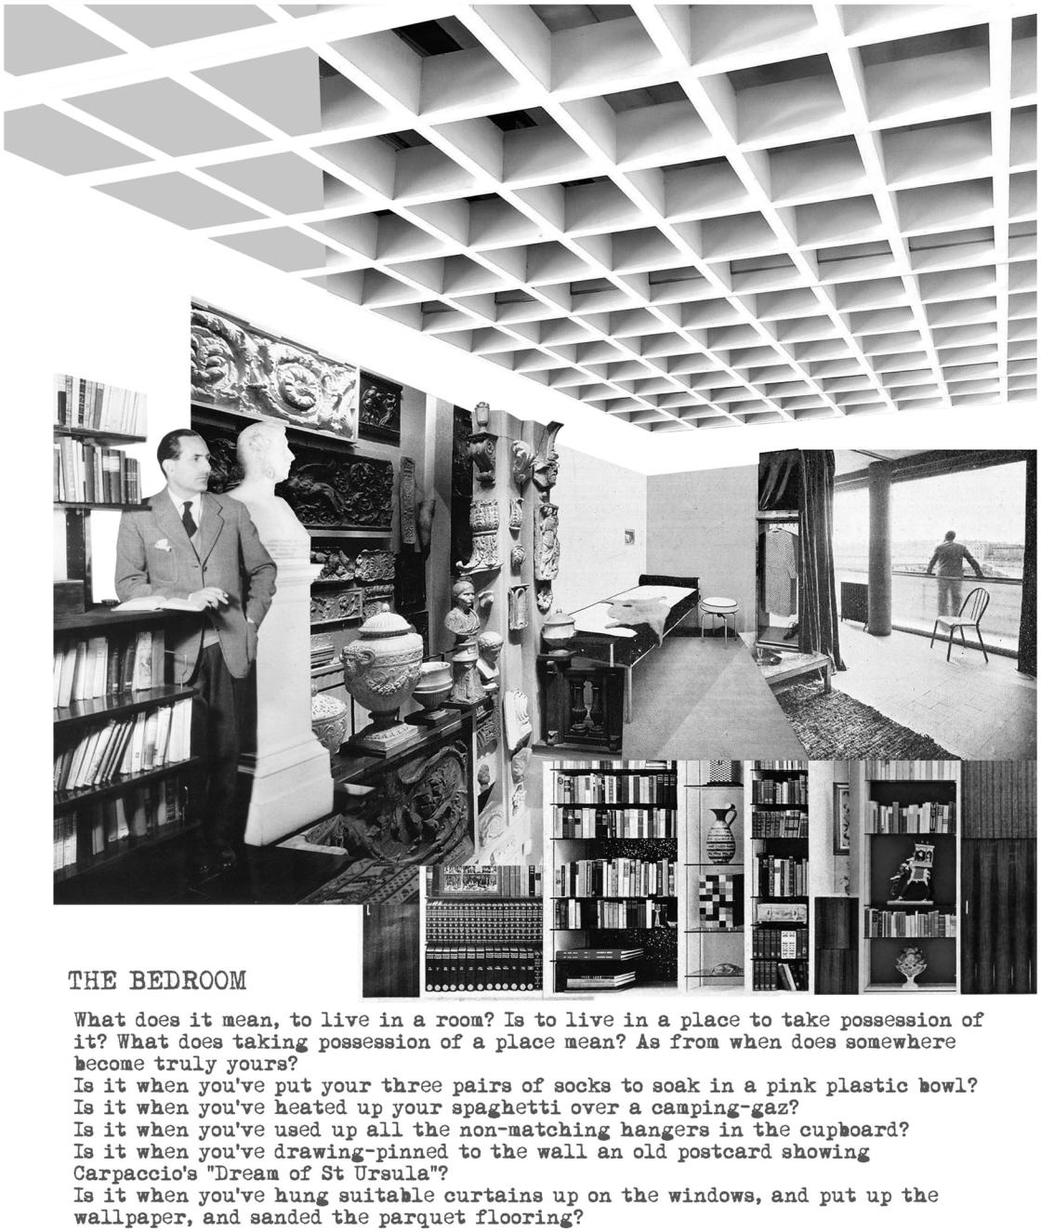

Figure 3

The Bedroom. Collage by Patrizio M. Martinelli.

|  |  |
| --- | --- |
| like ancient maps where names mean cities and places (where people | 7 |

live), and lines describe movements (of people) in time and space. Delving deeper into Species of Spaces, there are three lenses

through which Perec describes the spaces we live in. The first of these

relates to his interest in the banality of everyday life. His reflections,

which began with his involvement in the journal Cause Commune, directed

by Paul Virilio, are actually on the common, unremarkable, simple events

of ordinary life, on what Virilio calls the infraordinary, rather than the

extraordinary.17 Perec says that very clearly: he wants to speak about the

common things, “track them down and give them a meaning, a tongue, to

let them finally speak of what it is, of what we are ( … ) not the exotic

anymore, but the endotic.”18 Endotic is a neologism coined by Perec, the

“en-” meaning “in” or “within,” contrasting with “ex” meaning “out of” or

“from,” related to the infraordinary and hence to that family of words with

the Latin prefix “in” that includes interior, intimate, inside, internal: the

space inside and the space in-between, both domestic and urban – the

spaces of our everyday lives.19

The second lens is that through which Perec analyses the objects and spaces of our own experience, the places where we live our ordinary lives: the bed, the bedroom, the apartment, the apartment building, the street, the city, the countryside. To describe them, Perec uses a dialectical juxtaposition between scientific, analytical, objective dissection (that often takes the form of the list and of the diagrammatic inventory)20 focused on methodologies and scientific speculations, and a narrative based on free-floating digressions, on sequences of drifting and meandering that capture his imaginative musings and reflective discourses, autobiographical experiences and memories. Objective versus subjective. Abstraction versus evocation. Rational versus irrational (memories, fantasies, inventions). What you can see and measure versus what you cannot see or quantify (what is behind, beneath, beyond). The rational aspects of Perec’s poetics come from his belonging to the Oulipo movement, whose program was to maximize the conscious control of literary expression (through constraints, mathematical and geometrical structures, etc.) against the romantic and surrealistic emphasis on irrationality, genius, inspiration, spontaneity.21 On the other side, it is interesting to recall how Perec dealt with the realm of the unconscious in his 1973 book La Boutique obscure, which collects the dreams he dreamt between May 1968 and August 1972. As Bellos has pointed out, “unlike his other books … it had its roots not in a literary project but in a personal routine which was itself part of a development that led to the decision to undertake a course of psychoanalysis.”22 This is one of the strategies of the artist (architect, designer), his or her capacity to move in different realms, dimensions, and directions, between the rational and the imagination, between abstraction and memory, between the reality of the present and hopes and dreams for the future.

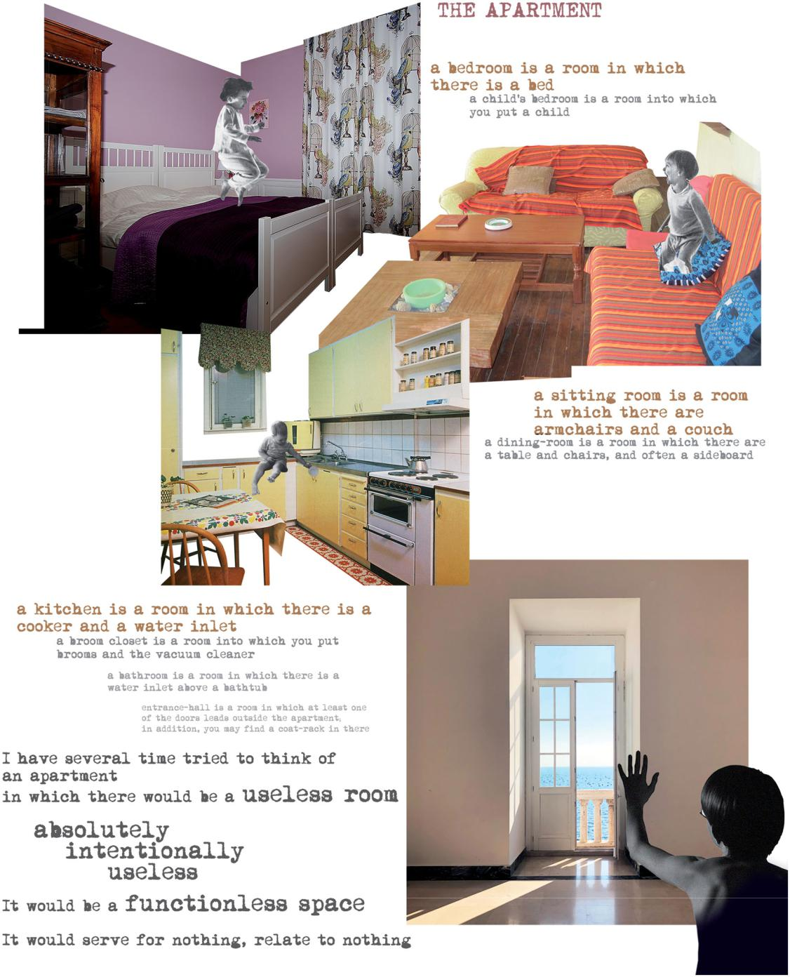

Figure 4

The Apartment. Collage by Patrizio M. Martinelli.

|  |  |
| --- | --- |
| The third important lens, which might relate Perec’s work more | 9 |

directly to that of designers, is framing. He was aware of the powerful tool of the frame: as mentioned, in Species of Spaces he describes Antonello da Messina’s painting “St Jerome in his Study,” represented inside the frame of a window. Not only framing space, though: the time-frame in the chapter “The Apartment” describes life inside the domestic interior hour by hour. Indeed, the whole structure of Life: A User’s Manual is represented by a compound frame (for space and time): the building without fac¸ade that keeps all the apartments and all the lives of its inhabitants together, within which the search for “what’s going on” continues behind the

(removed) wall.23

So for me, dealing with Species of Spaces always meant to investigate, to research “what’s going on” behind and inside the pages. The apparent simplicity and banality of his stories, opposed to the complexity of structure and the enigmatic references, always encouraged me to go deeper in this investigation, discovering, in every re-reading, opportunities to understand the author, his body of work, but most of all, the spaces we live in and that we (as architects) design. And this particular issue of Architecture and Culture presented me with another opportunity to enjoy and most of all to return to and work on Species of Spaces, de-composing it and analyzing it, using the book both as the object of my research and as a tool.

Like Perec, I tried to keep image and text together, melting them one in the other. Like Perec, I introduced autobiographical components into my visual compositions, often switching from the objectivity of the architectural imaginary to more personal and subjective juxtapositions. Like Perec with his masters, I used collage as a powerful tool to express what Henri Focillon defines as “spiritual groups,” “ancestors and friends” who “are not recollection, but presence” for the artist. In his book The Life of Forms in Art, Focillon wrote that the artist “may select examples and models from the past, and create from them a new and complete environment. He may, again, outline a future that simultaneously strikes into the present and the past.”24

In my visual investigation, a tribute to the legacy of his work and to his still-active presence in the world of art25 and architecture,26 the accurate montage of images, and their overlapping with Perec’s words drawn from the book itself (cut, re-arranged, re-created, pasted), is not the final stage of this review of, this return to, Species of Spaces, but the first phase of a renewed and enthusiastic relationship with these fruitful pages. Through these fragments and visions, it has been possible for me to find new evocations, suggestions and meanings, in order to deepen a reflection, a discourse and a project about the spaces and the quality of our houses, buildings and cities. This happens by following Perec’s pages, which, as Victoria Hunter expresses it, “range from the physical to the imaginative and challenge the reader to consider a multi-layered

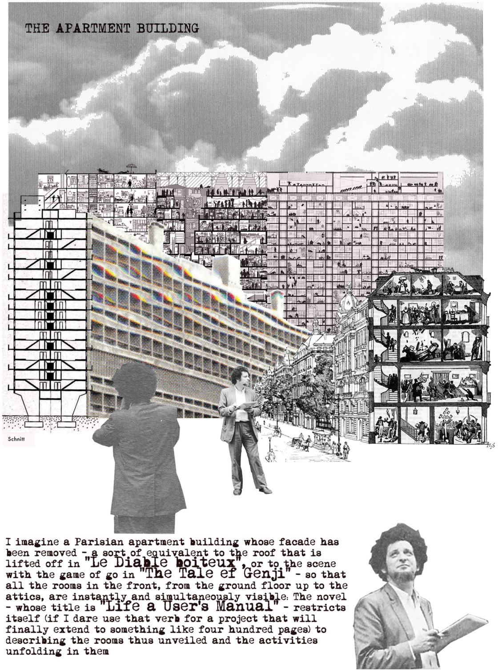

Figure 5

The Apartment Building. Collage by Patrizio M. Martinelli.

|  |  |  |
| --- | --- | --- |
| approach to experiencing and engaging with the built environment and | | 11 |
| cityscapes.”27 |  |  |
| This multi-layered space, as Bruno Zevi wrote in Architecture as | |  |
| Space, is the “protagonist of architecture;” it is the interior space of the | |  |
| home, of the palace, of the public building (almost impossible to describe | |  |
| or represent), but also the urban interiors of the “environment, the stage | |  |
| on which our life unfolds.”28 Space is a container of things (meticulously | |  |
| described in one of the first novels Perec wrote, Things: A Story of the | |  |
| Sixties) created by a “constellation of natural and man-made objects”29 in | |  |
| which man acts, like an actor on a private (the home) or public (the city) | |  |
| stage: this architecture as “the fixed stage for human events”30 is clearly | |  |
| represented in the pages of Perec, who often staged the events in his | |  |
| novels as theatrical plays - and who also wrote for cinema and theater.31 | |  |
| The bedroom is the place where, through objects (socks, plastic | |  |
| bowls, postcards pinned on the walls, curtains, wallpapers, parquet | |  |
| flooring) and the leaving of traces of our existence (“The traces of its | |  |
| inhabitant are molded into the interior,” wrote Walter Benjamin),32 we | |  |
| take possession of the minimal space in which we represent ourselves in | |  |
| everyday life.33 The apartment is where, as in a theatrical play, the simple | |  |
| daily life and rituals of a family are described hour by hour, moving from | |  |
| room to room, mapping time and geometry of movements, describing | |  |
| interactions with objects, fixtures, pieces of furniture, recording the | |  |
| entrance and exiting of the actors in home’s topography: a mise-en-scene | |  |
| of the infraordinary in a domestic interior. The apartment building, | |  |
| imagined without its fac¸ade, reveals “the life of others” and the inventory | |  |
| of the “constellation of objects” in the interiors of each apartment - as in | |  |
| the nineteenth century representations of buildings drawn in section that | |  |
| often have been used for the cover of Life: A User’s Manual; in the | |  |
| building without a roof of Le Diable boiteux, cited in Species of Spaces;34 | |  |
| in the dollhouses Perec was interested in;35 in the stage sets for some | |  |
| plays (from Les Criminels, 1929, by F. Bruckner,€ | directed by G. Pitoeff,36 |  |

up to Boogeyman by Reza Abdoh, 1990), and the inhabited sections in Wes Anderson’s movies; and in Le Corbusier’s Unite d’Habitation, where the fac¸ade is an urban frame made of smaller frames providing a place that people can use to freely express themselves, each loggia being a small theatrical stage for the life of the dweller.

Also, when he writes about the street, Perec expresses his interest in its elements - in how it is made - and what is behind or below them. Observing comes first of all, then making lists of objects: inventories, catalogs, enumerations. He gives us a methodology for this “practical exercise” and he proposes this method several times in the book, the same method he used for his own work, for his own research:37 “Observe the street … try to describe the street, what it’s made of, what it’s used for.”38 Buildings, people, cars, dogs, birds. But then we find a jump beyond what we see in the streets. Just as when he “removes” the fac¸ade of the apartment building and asks us to imagine what lies behind

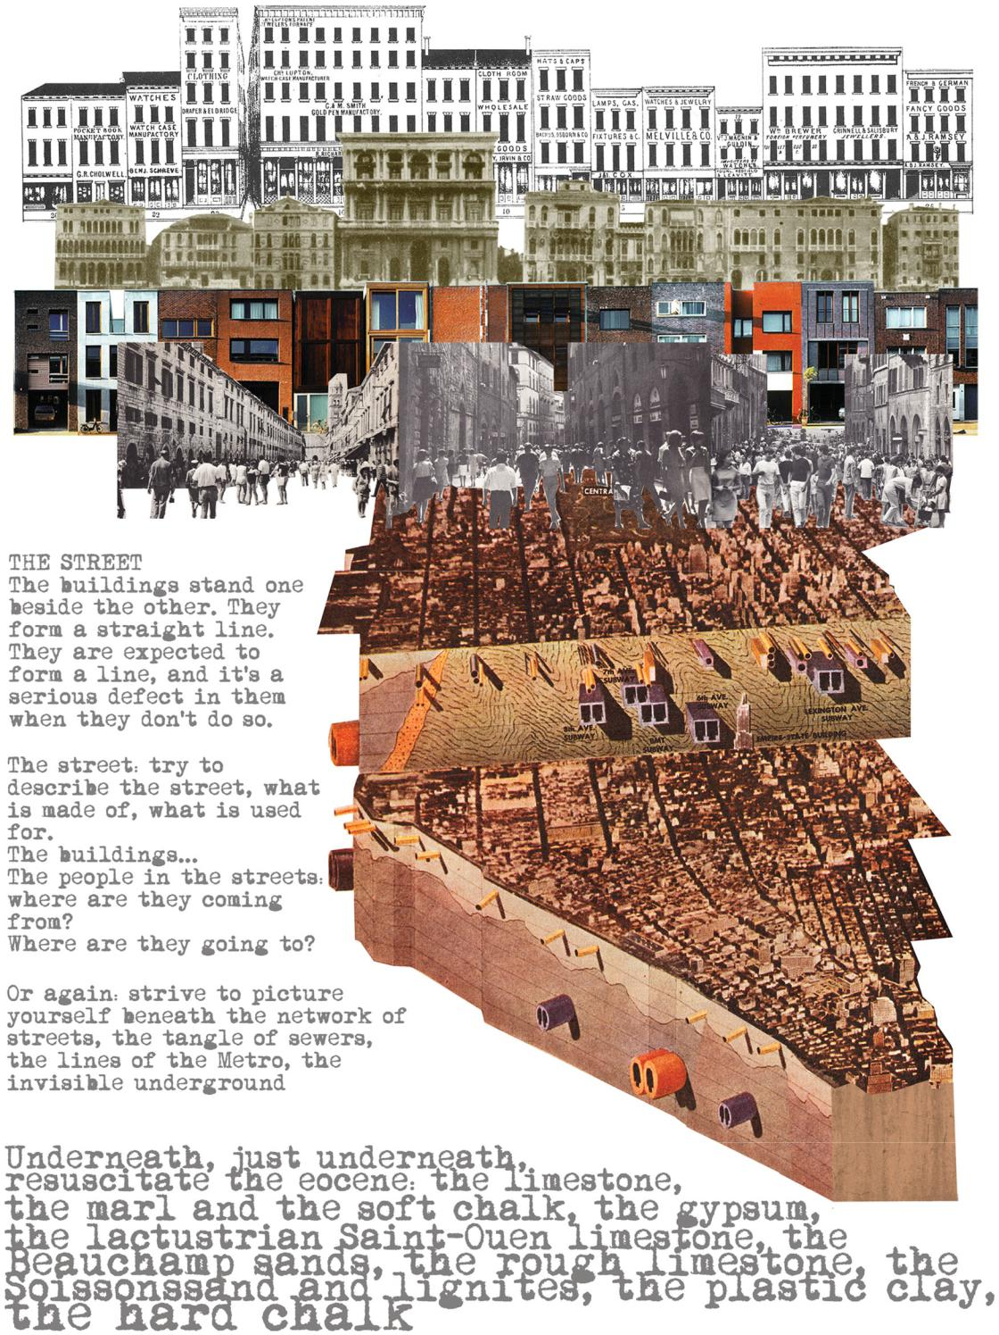

Figure 6

The Street. Collage by Patrizio M. Martinelli.

|  |  |
| --- | --- |
| it, here Perec pushes us to imagine what is beneath the street, the | 13 |

underground topographies and geographies, the mysterious world of conduits, the unknown layers of materials that lie under the asphalt, under our feet, hidden to our eyes. This is what he wants us to do: to go deeper, to go below, beyond and behind, to imagine, to be able to see what cannot be seen (as well as to see what can be seen).39

Of course, the act of living involves the spaces of the city.40 The

city, with buildings and streets, is both a backdrop and a big home (which

reminds us of Leon Battista Alberti’s assertion that the city can be read

as a big house, and the house as a small city). Perec’s invention and

“transgression”41 is to find spaces and places for people’s activities in

different parts of the urban environment: “why not have five or six rooms

dotted about Paris?,”42 sleeping here, reading there, making love in one

place, listening to music in another. Another transgression: what about

giving names to the rooms, starting not from the function they host? What

if we call them by the days of the week - Mondayery, Tuesdayery,

Thursdayery and so on? What if the names are based on our senses -

gustatorium, auditorium, smellery? What if we think of rooms without

functions, finally freed from the relationship form/function/name?

So the city can be read as a montage of rooms, of homes, of places, a montage of spaces and interiors:43 it is a collage (recalling Colin Rowe in the first place, but also Paul Citroen’s Metropolis or Großstadt, or Aldo Rossi’s La Citta Analoga) that works as a palimpsest of traces of different times, functions, styles, memories, stories, as a complex framework in which present and future unfold.44 This again raises questions: “What is the heart of the town? The soul of a town?”45 – as if it were a human being, and echoing Georges Chabot and Aldo Rossi46 – “You can go on endlessly piling up unanswerable questions.”47 Lists again: stones, concrete, asphalt, strangers, monuments, institutions, megalopolises, urban sprawls, traffic arteries, crowds. With all its contradictions, its espaces indicibles, its invisible mysteries, and its unanswerable questions, the city is the necessary place and necessary space for us to live. “It’s in the town that we breathe ( … ) There’s nothing inhuman in a town unless it’s our own humanity.”48 The city is the essence of our humanity, it is where and how we represent our own humanity. We clearly recall here what Ernesto N. Rogers wrote in 1946 about the “house of man” (and then again we have the overlapping of the domestic and the urban scale): “I want to have a house that looks like me (in a beautiful way): a house that represents my own humanity.”49 Or Mario Praz’s interpretation of the domestic interior as “a projection of the ego” and as “a mirror of the spirit.”50

Perec, who defines himself as a “man of the towns,” cannot speak about anything other than that. The countryside? “The countryside doesn’t exist, it’s an illusion … the countryside is a foreign land.”51 It can be evoked only as a utopia. It is probably impossible to re-create the scenarios he depicts in his “village utopia” paragraph: we have lost that

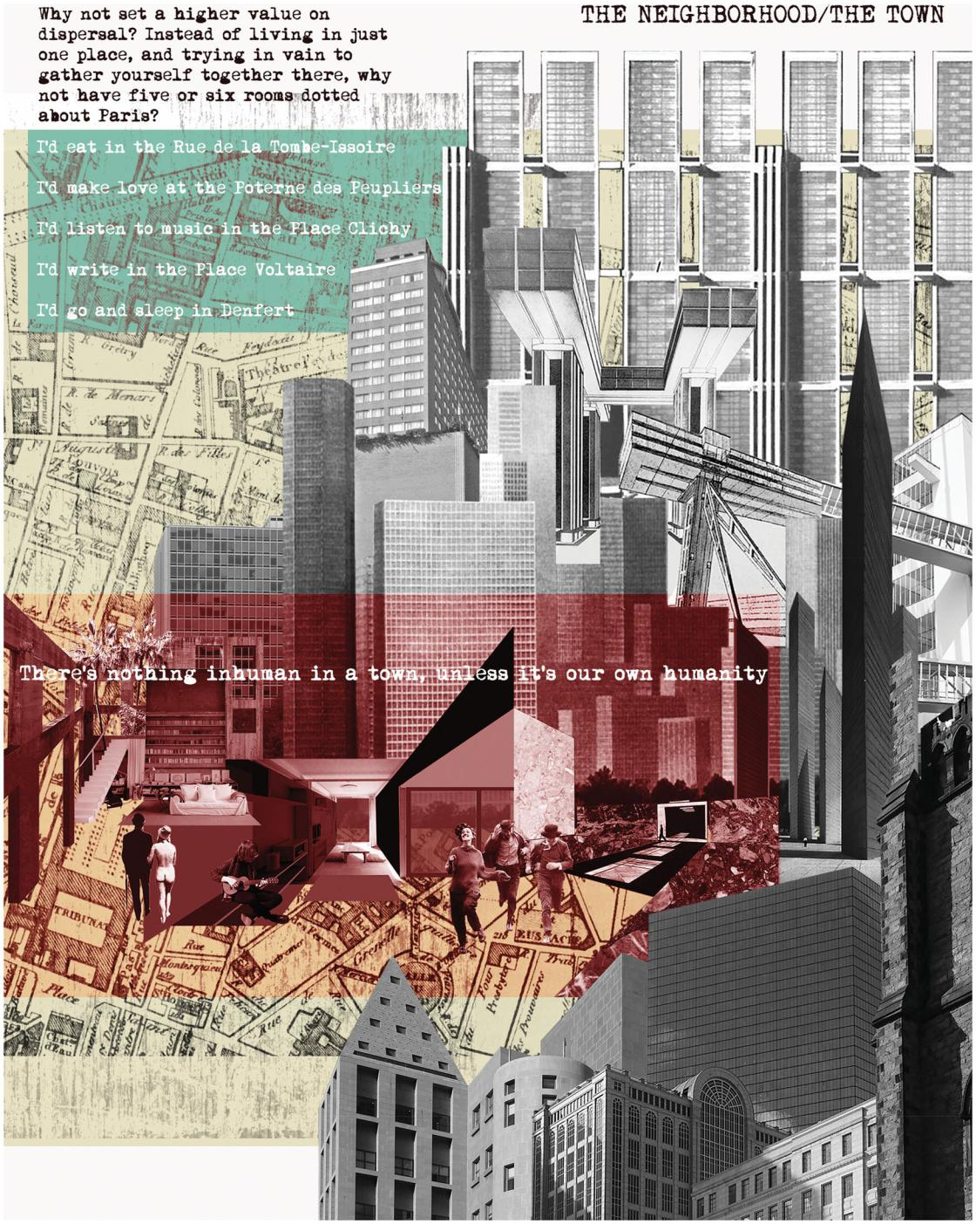

Figure 7

The Neighborhood/The Town. Collage by Patrizio M. Martinelli.

|  |  |
| --- | --- |
| perfect harmony between nature and man, the small scale of things, the | 15 |

slow rituals of human actions and natural events, the minimal joys of a simple life. It is a powerful paragraph, as powerful as a fairy-tale about a lost world. In fact, while the book is definitely and by its author’s own admission a hymn to the city and its spaces, this chapter on the countryside is the perfect counterpoint of the dialectical discourse about these topics. The countryside does not belong to the everyday life of the urban citizen represented by Perec. The countryside is the external space, opposed to the internal space of the city. It doesn’t exist because it doesn’t have interiors. It’s the exotic (not the endotic), the extraordinary (not the infraordinary), it is literally what is represented by the Latin expression extra-moenia: what is outside the walls of the city. Outside versus inside.

And toward the end, the journey through the different categories of space takes us back to the human scale, with the description of a piece of furniture, the representation of St. Jerome’s wooden study made by Antonello da Messina. This painting defines an individual device (an enhanced desk: actually a minimal place for working) designed for a series of functions, that informs by its presence/essence the bigger space of the cathedral in which it is located. The description is an analytical dissection of parts and elements, describing the space inhabited by the saint, his objects and animals, whose dimensions are in a relationship with his body and his actions. The geometry of working and of staying builds every element of the structure: anthropometry and ergonomics are the matrices of this minimal space that reverberates in the bigger space of the cathedral. Here the multiple scales of our environment are kept together: the human body that stays and acts, in a room that is a collective space, a covered square for the community of the city.

From the room to the city, from the domestic interior to the exterior of the streets and the city, these “spaces of every kind and every size, for every use and every function” are made for our life. And to live “is to pass from one space to another, while doing your very best not to bump yourself.”52

POSTSCRIPT

The collages presented in this visual essay contain the following:

“spiritual groups,” “ancestors and friends,” fragments and visions (in no particular order): Le Corbusier, Ignazio Gardella, Franc¸ois Truffaut, Luigi Moretti, Venice, John Soane, Kevin Roche, Andreij Tarkovskij, Amsterdam, Luis Barragan, the American High Street, SOM, Eero Saarinen, Urban Design Manhattan, Superstudio, Ricardo Bofill, Boston, Michael Graves, Mart Stam, Ivan Leonidov, Rino Levi, Brasilia, Steven Holl, Cincinnati, Mexico City, Jeanne Moreau, Paris, Detroit, Beijing, Anghiari, Eugene Henard, Bertall, and of course, Georges Perec.53

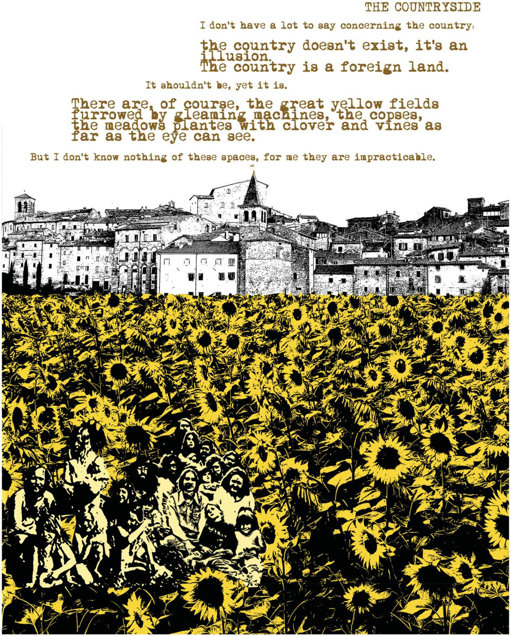

Figure 8

The Countryside. Collage by Patrizio M. Martinelli.

|  |  |
| --- | --- |
| Patrizio M. Martinelli has been Assistant Professor at Miami University, | 17 |

Oxford (Ohio) since 2017. He studied at the Istituto Universitario di

Architettura di Venezia (IUAV) where he earned a Master’s degree in

Architecture and a PhD in Architectural Composition. At the IUAV he was

involved in teaching and research, receiving grants and fellowships to

study domestic interiors, adaptive reuse of industrial buildings and urban

regeneration. From 2007 to 2016 he was a guest critic at the Munster€

School of Architecture (Germany). His research has been published in his

own monographs and in architectural magazines, and presented at

conferences in Europe and the USA.

Notes

1. The first French edition came out in 1974: Georges Perec, Especes d’espaces (Paris,

France: Edition Galilee, 1974). The first version of the book I read was the Italian one: Georges Perec, Specie di spazi, trans. Roberta Delbono (Torino, Italy: Bollati Boringhieri, 1989). For this paper I worked with the English translation: Georges Perec, Species of Spaces and Other Pieces, trans. and ed. John Sturrock (London, UK: Penguin Book Ltd., 1997). Similarly, for Life: A User’s Manual, my research moved between the following versions: Georges Perec, La vie mode d’emploi (Paris, France:

Edition Hachette, 1978); Georges Perec, Vita. Istruzioni per l’uso, trans. Daniella Selvatico Estense (Milano, Italy: BUR,

1984); and Georges Perec, Life: A User’s Manual, trans. David Bellos (London, UK: Harvill/HarperCollins, 1992).

1. As he explains at the beginning of the chapter “The Apartment Building” - see Perec, Species of Spaces, 40.
2. Tania Ørum, “Georges Perec and the Avant-Garde in the Visual Arts,” Textual Practice 20, no. 2 (2006): 320.
3. David Gascoigne, “Georges Perec’s La Vie Mode d’Emploi; or How to Take on Painting and Win,” Nottingham French Studies 51, no. 3 (2012): 286.
4. In the article “Defense of Klee,” as quoted in David Bellos, Georges Perec: A Life in Words (London, UK: The Harvill Press, 1995), 212.
5. Georges Perec, Entretiens et conferences, vol. 1, ed. Dominique Bertelli and Mireille Ribiere, trans. Mireille Ribiere (Nantes, France: Joseph K., 2003), 186.
6. In an interview published in AA files, Pierre Getzer recalls “a reproduction of a

painting I did around 1970–2. Georges Perec had it in front of him for years. It combines things I had seen with plates taken from the review of the Parisian studio of urbanism, Paris-Project.” See Jean-Charles Depaule and Pierre Getzler, “A City in Words and Numbers,” AA Files 45/46 (2001): 117.

1. Gotthold E. Lessing, Laocoon: An Essay on the Limits of Painting and Poetry (Baltimore, MD: The Johns Hopkins University Press, 1984).
2. Gascoigne, “Georges Perec’s La Vie Mode d’Emploi,” 295–296.
3. Ibid., 291–293.
4. On literary collage/montage, see the chapter “Verbal Paste-ups” in Jeanine Parisier Plottel, ed., Collage, vol. 10–11, (New York, NY: New York Literary Forum, 1983).
5. See the chapter “Citations” in Hans Hartje, Bernard Magne, and Jacques Neefs, eds., Georges Perec: Cahiers des charges de La Vie mode d’emploi (Paris and Cadeilhan, France: CNRS Editions/ Zulma, 1993). The postscript of Perec’s Life: A User’s Manual is the list of all these presences: see Perec, Life: A User’s Manual, 579.
6. “It is hard to convey the extraordinary diversity of his writings. From 1965 to his premature death, he created novels, poems, plays, short experimental exercises, musical and filmic collaborations, and work with visual artists.” Alison James, Constraining Chance: Georges Perec and the Oulipo (Evanston, IL: Northwestern University Press, 2009), 17. For an exhaustive,

18

Fragments and Visions of a Spatial Discourse: Re-Viewing Georges Perec’s Species of Spaces

Patrizio M. Martinelli

monumental biography of Perec, see Bellos, Georges Perec: A Life in Words.

1. See, in particular, Stefanie Elisabeth Sobelle, “The Novel Architecture of Georges Perec,” in Writing the Modern City: Literature, Architecture, Modernity, eds. Sarah Edwards and Jonathan Charley (London, UK; New York, NY: Routledge, 2011); Peta Mitchell, “Constructing the Architext: Georges Perec’s ‘Life a User’s Manual,” Mosaic: An Interdisciplinary Critical Journal 37, no. 1 (2004); Maria Consuelo Ortiz M., “L’Autobiographie chez Perec: le Cas d’Especes d’Espaces,” Romanische Forschungen 107 (1995); David Bellos, “Writing Spaces: Perec in Perspective,” Cambridge Architectural Journal

9 (1997–8).

1. In the pages of Species of Spaces, Perec refers to other literary projects he was working on: Life: A User’s Manual (in the chapter “The Apartment Building”), Lieux (in the chapter “The Bedroom”), Lieux ou j’ai dormi (in the chapter “The Street”). See David Gascoigne, The Games of Fiction: Georges Perec and the Modern French Ludic Narrative (Bern, Switzerland: Peter Lang, International Academic Publishers, 2006), 170–171.
2. Perec, Species of Spaces, 5, 13.
3. Cause Commune was founded in 1971 by the sociologist Jean Dauvignaud, and Paul Virilio and Perec made important contributions. The journal “announced a set of sociological, political and anthropological goals, among them an ‘investigation of daily life at all its levels in its recesses and caverns that are generally disdained and repressed’.” James, Constraining Chance, 198. See also Georges Perec, L’infra-

ordinaire (Paris, France: Seuil, 1989). For reflections on the relationship between Perec and Virilio, see Enrique Walker and Paul Virilio, “Paul Virilio on Georges Perec,” AA Files 45–46 (2001): 15–18.

1. Georges Perec, “Approaches to What?” in Species of Spaces, 210 (first published in Cause Commune February 1973).
2. For a deep investigation of this topic see Maria Consuelo Ortiz M.,

“L’endotique: thematique et forme de

l’infra-ordinaire. Une analyse de l’oeuvre

de Georges Perec” (Ph.D. diss., University of Cincinnati, 1997).

1. On the topic of the list see Umberto Eco, The Infinity of Lists: An Illustrated Essay, trans. Alastair McEwen (Milan, Italy: Rizzoli International, 2009).
2. James, Constraining Chance.
3. Bellos, Georges Perec, 530.
4. “Granted there is a wall, what’s going on behind it?” is a quote by French playwright Jean Tardieu that Perec uses in “The Apartment” chapter of Species of Spaces. See Perec, Species of

Spaces, 39.

1. “Although every individual is contemporary first of all with himself and with his generation, he is also contemporary with the spiritual group of which he is a member. This is even more the case as regards the artist, because to him his ancestors and friends are not recollection, but presence. They stand immediately before him, in full life ( … ). The artist inhabits a country in time that is by no means necessarily the history of his own time ( … ) with equal consistency he may select examples and models from the past, and create from them a new and complete environment. He may, again, outline a future that simultaneously strikes into the present and the past.” Henri Focillon, The Life of Forms in Art, trans. Charles B. Hogan and George Kubler (New York, NY: Zone Books, 1989 [1934]), 134, 154.
2. Mireille Ribiere, “Georges Perec’s Enduring Presence in the Visual Arts,” in The Afterlives of Georges Perec, eds. Rowan Wilken and Justin Clemens (Edinburgh, UK: Edinburgh University Press, 2018), 23–44.
3. Sandra Kaji-O’Grady, “The Architecture of Constraint and Forgetting,” in The Afterlives of Georges Perec, 171–188.
4. Victoria Hunter, “Perecquian Perspectives: Dialogues with Site-Dance (Or, ‘On being here and there’),” Literary Geographies 3, no. 1 (2017): 34.
5. Bruno Zevi, Architecture as Space: How to Look at Architecture, ed. Joseph A. Barry, trans. Milton Gendel (New York, NY: Horizon Press, 1974 [1948]), 32. In his book Zevi makes some proposals on how to represent interior space through drawings, diagrams and schemes.

Another interesting tentative suggestion for representing interior space was made by the Italian architect Luigi Moretti in the 1950s, for research published in the magazine Spazio. There, as well as a small number of analytical graphic diagrams, Moretti published photographs of models of interior space, quasi sculptures of the volume that is defined by the interior surfaces of a building. No walls, no pillars, no windows or doors, no exterior or interior facades, but only volumes used to describe the interior spaces and their relationships. These abstract procedures transform the building into a sort of cast of the negative interior space, made into a positive and concrete object. The models of some of these spaces have been used in the collage “The Page” I present here. See Luigi Moretti, “Strutture e sequenze di spazi,” Spazio 7 (1952–1953).

1. Rudolf Arnheim, The Dynamics of Architectural Form (Berkeley, CA: University of California Press, 1977), 13.
2. “Architecture, attesting to the tastes and attitudes of generations, to public events and private tragedies, to new and old facts, is the fixed stage for human events. The collective and the private, society and the individual, balance and confront one another in the city.” Aldo Rossi, The Architecture of the City, trans. Diane Ghirardo and Joan Ockman (Cambridge, MA: MIT Press, 1984 [1966]), 22.
3. Perec wrote three plays in German, five short texts and two major works in French, L’Augmentation and La Poche Parmentier. See the chapter “Poetry, Theater, and Film” in Paul Schwartz, Georges Perec: Traces of His Passage (Birmingham, UK: Summa Publications, Inc., 1988).
4. Walter Benjamin, The Arcades Project, trans. Howard Eiland and Kevin McLaughlin (Cambridge, MA: The Belknap Press of Harvard University Press, 1999), 20.
5. See Erving Goffman, The Presentation of Self in Everyday Life (Edinburgh, UK: University of Edinburgh Press, 1956).
6. Perec, Species of Spaces, 40.

|  |  |
| --- | --- |
| 35. Perec had postcards representing them | 19 |

in his archive. See Jacques Neefs and

Hans Hartje, Georges Perec: Images

(Paris, France: Editions du Seuil,

1993), 151.

1. See Denis Bablet, ed., Collage et montage au the ^atre et dans les autres arts durant les annees vingt (Lausanne, Switzerland: La Cite-L’Age d’Homme, 1978).
2. A collection of these lists and notes (and the reproductions of the original documents) related to Life: A User’s Manual is published in Hartje, Magne, and Neefs, Georges Perec: Cahiers

des charges.

1. Perec, Species of Spaces, 50.
2. This was clear from the first pages of the journal Cause Commune: “Metaphors of depth predominate in this editorial pronouncement: everyday life, far from being the visible surface of the real, possesses its own underground geography.” James, Constraining Chance, 198
3. The original French term used by Perec in Species of Spaces is “ville,” which I consider closer to “city” than “town.” The English translation of the book has “town” for “ville.”
4. “In Perec, the use of space is no longer to be taken for granted; it assumes unexpected uses, transgressions that are the linguistic corollary of life (le vecu) in a moment of social reconstruction.” Maria Consuelo Ortiz M., “L’endotique,” 118. Translation from French by the author.
5. Perec, Species of Spaces, 59.
6. As Georges Teyssot points out, the buildings of the nineteenth century city are “large spaces that create vast interiors for the collective … they are all interior:” the arcades, the glasshouses, the enclosed rooms of panoramas, museums and casinos, the halls of factories and railway stations. They are containers of crowds that enclose the collective dream, public spaces of the city appearing as interiors in which citizens live, work, and represent themselves as though in a theatrical play. See Georges Teyssot, “Thresholds and Folds: Issues of Interiority,” Casabella 681 (2000): 92.

20

Fragments and Visions of a Spatial Discourse: Re-Viewing Georges Perec’s Species of Spaces

Patrizio M. Martinelli

1. See Colin Rowe and Fred Koetter, Collage City (Cambridge, MA: MIT Press, 1978); the chapter “Photomontage and the Metropolis” in Martino Stierli, Montage and the Metropolis: Architecture, Modernity and the Representation of Space (New Haven, CT: Yale University Press, 2018); and Aldo Rossi’s compositional concept of the analogous city, first mentioned in the introduction to The Architecture of the City, then produced as a collage for the 1976 Venice Biennale and published

as “La citta analoga: tavola / The

analogous city: panel” in Lotus, no. 13, 1976, 5–9.

1. Perec, Species of Spaces, 61.
2. “( … ) many [scholars of the city] have recognized that beyond the elements they had enumerated there remained the ^ame de la cite, in other words, the quality of urban artifacts. ( … ) In particular I mentioned the work of

References

– Arnheim, Rudolf. 1977. The Dynamics of Architectural Form. Berkeley, CA: University of California Press.

– Bablet, Denis, ed. 1978. Collage et montage au theatre et dans le autre arts durant les annees vingt. Lausanne, Switzerland: La Cite-L’Age d’Homme.

– Bellos, David. 1995. Georges Perec: A Life in Words. London, UK: The Harvill Press.

– Bellos, David. 1997–8. “Writing Spaces: Perec in Perspective.” Cambridge Architectural Journal 9, 11–18.

– Benjamin, Walter. 1999. The Arcades Project, translated by Howard Eiland and Kevin McLaughlin. Cambridge, MA: The Belknap Press of Harvard University Press.

– Depaule, Jean-Charles and Pierre Getzler. 2001. “A City in Words and Numbers.” AA Files 45/46: 117–128.

– Eco, Umberto. 2009. The Infinity of Lists: An Illustrated Essay, translated by Alastair McEwen. Milan, Italy: Rizzoli International.

– Focillon, Henri. 1989 [1934]. The Life of Forms in Art, translated by Charles B. Hogan and George Kubler. New York, NY: Zone Books.

– Gascoigne, David. 2006. The Games of Fiction: Georges Perec and the Modern

Chabot, for whom the city is a totality that constructs itself and in which all the elements participate in forming the ^ame de la cite.” Rossi, The Architecture of the City, 32, 55.

1. Perec, Species of Spaces, 62.
2. Ibid.
3. Ernesto N. Rogers, “Programma: Domus, la casa dell’uomo,” Domus 205 (1946): 3. Translation from Italian by the author.
4. Mario Praz, An Illustrated History of Interior Decoration: from Pompeii to Art Nouveau, trans. William Weaver (New York, NY: Thames and Hudson, 1982 [1964]), 21, 50.
5. Perec, Species of Spaces, 69.
6. Ibid., 6.
7. My postscript here is intended to echo - and to borrow from - Perec’s at the end of Life: A User’s Manual, 579.

French Ludic Narrative. Bern, Switzerland:

Peter Lang, International Academic Publishers.

– Gascoigne, David. 2012. “Georges Perec’s La Vie Mode d’Emploi; or How to Take on Painting and Win.” Nottingham French Studies 51, no. 3: 286–297.

– Goffman, Erving. 1956. The Presentation of Self in Everyday Life. Edinburgh, UK: University of Edinburgh Press.

– Hartje, Hans, Bernard Magne, and Jacques Neefs, eds. 1993. Georges Perec: Cahiers des charges de La Vie mode d’em-ploi. Paris and Cadeilhan, France: CNRS Editions/Zulma.

– Hunter, Victoria. 2017. “Perecquian Perspectives: Dialogues with Site-Dance (Or, ‘On being here and there’).” Literary Geographies 3, no. 1: 27–49.

– James, Alison. 2009. Constraining Chance: Georges Perec and the Oulipo. Evanston, IL: Northwestern University Press.

– Kaji-O’Grady, Sandra. 2017. “The Architecture of Constraint and Forgetting.” In The Afterlives of Georges Perec,

171–188. Edinburgh, UK: Edinburgh University Press.

– Lessing, Gotthold E. 1984. Laocoon: An Essay on the Limits of Painting and Poetry. Baltimore, MD: The Johns Hopkins University Press.

– Mitchell, Peta. 2004. “Constructing the Architect: Georges Perec’s ‘Life a User’s Manual.” Mosaic: An Interdisciplinary Critical Journal 37, no. 1: 1–16.

– Moretti, Luigi. 1952–53. “Strutture e sequenze di spazi.” Spazio 7: 9–20.

– Neefs, Jacques and Hans Hartje. 1993. Georges Perec: Images. Paris, France:

Editions du Seuil.

– Ortiz M., Maria Consuelo. 1995. “L’Autobiographie chez Perec: le Cas d’Especes d’Espaces.” Romanische Forschungen 107: 157–162.

– Ortiz M., Maria Consuelo. 1997. “L’endotique:

thematique et forme de l’infra-ordinaire. Une analyse de l’oeuvre de Georges Perec.” Ph.D. diss., University of Cincinnati.

– Ørum, Tania. 2006. “Georges Perec and the Avant-Garde in the Visual Arts.” Textual Practice 20, no. 2: 319–392.

– Parisier Plottel, Jeanine, ed. 1983. Collage, vol. 10–11. New York, NY: New York Literary Forum.

– Perec, Georges. 1974. Especes d’espaces.

Paris, France: Edition Galilee.

– Perec, Georges. 1978. La vie mode d’em-

ploi. Paris, France: Edition Hachette.

– Perec, Georges. 1984. Vita. Istruzioni per l’uso, translated by Daniella Selvatico Estense. Milano, Italy: BUR.

– Perec, Georges. 1989. L’infra-ordinaire. Paris, France: Seuil.

– Perec, Georges.1989. Specie di spazi, translated by Roberta Delbono. Torino, Italy: Bollati Boringhieri.

– Perec, Georges. 1992. Life: A User’s Manual, translated by David Bellos. London, UK: Harvill/HarperCollins.

– Perec, Georges. 1997. Species of Spaces and Other Pieces, edited and translated by John Sturrock. London, UK: Penguin.

– Perec, Georges. 2003. Entretiens et con-

ferences, vol. 1, edited by Dominique Bertelli and Mireille Ribiere and translated

|  |  |
| --- | --- |
| by Mireille Ribiere. Nantes, France: Joseph | 21 |

K.

– Praz, Mario. 1982 [1964]. An Illustrated History of Interior Decoration: From Pompeii to Art Nouveau, translated by William Weaver. New York, NY: Thames and Hudson.

– Ribiere, Mireille. 2018. “Georges

Perec’s Enduring Presence in the Visual

Arts.” In The Afterlives of Georges Perec,

23–44. Edinburgh, UK: Edinburgh

University Press.

– Rogers, Ernesto N. 1946. “Programma:

Domus, la casa dell’uomo.” Domus 205:

2–3.

– Rowe, Colin and Fred Koetter. 1978.

Collage City. Cambridge, MA: MIT Press.

– Rossi, Aldo. 1984 [1966]. The Architecture of the City, translated by Diane Ghirardo and Joan Ockman. Cambridge, MA: MIT Press.

– Rossi, Aldo. 1976. “La citta analoga: tavola / The analogous city: panel.” Lotus, no. 13, 5–9.

– Schwartz, Paul. 1988. Georges Perec:

Traces of His Passage. Birmingham, UK:

Summa Publications, Inc.

– Sobelle, Stefanie Elisabeth. 2011. “The Novel Architecture of Georges Perec.” In Writing the Modern City: Literature, Architecture, Modernity, edited by Sarah Edwards and Jonathan Charley,

178–190. London, UK; New York, NY:

Routledge.

– Stierli, Martino. 2018. Montage and the

Metropolis: Architecture, Modernity

and the Representation of Space. New

Haven, CT; London, UK: Yale University

Press.

– Teyssot, Georges. 2000. “Thresholds and Folds: Issues of Interiority.” Casabella 681: 92–96.

– Walker, Enrique and Paul Virilio. 2001. “Paul Virilio on Georges Perec.” AA Files 45–46: 15–18.

– Zevi, Bruno. 1974 [1948]. Architecture as Space: How to Look at Architecture, edited by Joseph A. Barry and translated by Milton Gendel. New York, NY: Horizon Press.